**Product Information**

**Brand Name**: FULREE

**Model No.** : C240505

**Product Property (Type)**: Non-isolated buck converter

**Input Voltage**: DC 12-24V (8-36V)

**Output Current**: 5A Max

**Output Power**: 25W

**Efficiency**: More than 95%

**Operating Temperature**: -40℃ ~ +85℃

**Waterproof Rating**: IP67

**Cable Length**: 13-14cm

**Size**: 66*60*22mm

**Static Power**: Less than 10mA

**Cooling Way**: Passive heat removal (Free air convection)

**Packaging**: Anti-static bag

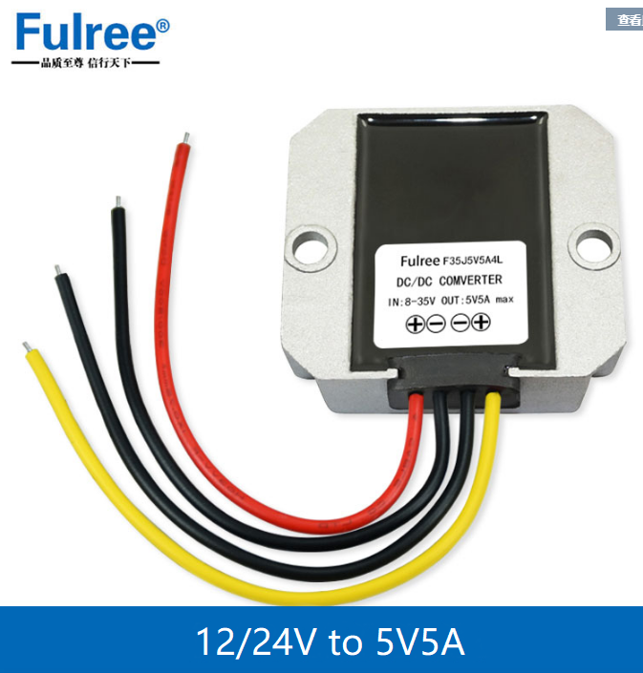

Dimension Drawing

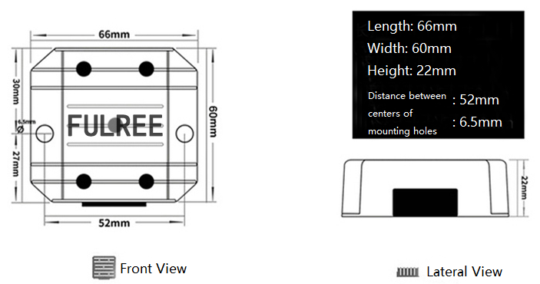

Connection Method

